**1. Definition and Analysis**

**1.1 Definition – Nature of problem**

**1.1.1 Description of organization**

This project is designed to solve the problems of tournament statistics, membership management, draw management and handicap calculations in Bombay Presidency Golf Club (BPGC). It is a golf club which dates back over 5 decades and has been the central hub for golfing in Mumbai.

With an increase in memberships and more number of golfers there has been a problem of calculating scores of many individuals due to lack of human resource. The computerised system will make golf calculations easier and accurate as well as make it easier for members to access.

OLD BPGC: Golf is a game that has not changed very much since its inception over 5 centuries ago. People who understand the game well are able to calculate various statistics about their game. It is not as complicated as perceived but the sheer number of people taking interest in the game has caused problems in giving results faster and accurately.

The traditional method has always been adding up the scores and using different formulae to calculate different sort of scores eg: gross score, net scores. These processes require a certain level of mathematical quotient which is not possessed by all hence a group of 5 people in the club do this. During crowed days catering to each individual is a difficult task. This leaves some members dissatisfied.

Golf is a game that has been enjoyed over the centuries due to composure and skills of the players. It has not been subjected to change but the way in which scores are calculated must evolve with times making average golfers less dependent on a group of people.

**1.1.2 Methods currently in use**

The calculations are done on the golf scorecard by individuals on normal days. They are only able to calculate a very vague image of their game progress. During major tournaments use of MS Excel is common but due to the complex nature of the software it is difficult if the official using excel is not present. The handicap is also calculated through a Microsoft excel spreadsheet which is updated every month, despite the accurate results members can only access their handicap for the month and cannot see their handicap of previous months or their statistics of every hole on the course. The handicaps are displayed in the form of a print out with each members handicap listed. Draws for the tee time are done manually where the officials have to sift through large amounts of names and compare them with the handicaps and place them accordingly. Cancellations and last Minuit additions are a problem for officials. Usually during tournaments involving teams tee times are fixed in convenience of the opposing teams. The general details of the members are not in the access of the golf hut hence the communication between the reception and golf hut is crucial which is lapsed in some cases leaving members frustrated. Results of tournaments are usually displayed after a few hours or maybe days after the tournament which results in members calling frequently for their result.

**1.2 Investigation and Analysis**

**1.2.1 – Plan of Investigation**

The first step in developing any program is by investigating the problem its cause and finding solutions to respective problems. Like a doctor must do a thorough diagnosis of a patient before giving a medical advice, investigation of the problem is the first important step towards finding a proper solution and in this case, developing a useful program for BPGC. In this case, the problem faced by the User must be studied first and the perspective of the user must be considered hence the aim for this investigation, therefore, would be able to understand and analyze and then attempt to solve the problem from the User’s perspective. We must understand the current system thoroughly and understand both the benefits and drawbacks of this hence gain an insight of the basic problem.

The common and the most effective methods of investigations are:

1. ***Studying records and documents of the organization:*** The main documents that exist in the golf club are records of the members, handicap (explained later) and scorecards. This helps in understanding the data types required and the problems in the current system.
2. ***Observation of the user working:*** The golf hut is run by a team of four officials the main observation of their work in interacting with the golfers and ways of calculating scores would be seen. This would give a relatively good idea of the functioning of the club and problems encountered. This is a practical viewpoint and helps to understand the problem from the viewpoint of a system developer.
3. ***Interviewing the user on the system:*** Interviews of the users of the system and golfers would help to understand the problems on both sides of the coin. The expectations of both the user and player will be addressed.

Then we must then take into consideration what level of technology and data management is used by the organization:

1. ***Finding the types of data input:*** The data types e.g. date, Boolean for male or female, alphanumeric for addressee
2. ***Finding methods of data input:*** We must first get an understanding of the current data inputs of the users and gain understanding of problems. E.g. If data input is manual we can deduce that the main problems are manual errors
3. ***Finding data storage systems and methods:*** The details of how data is stored and where it is stored e.g.: Manual entries in diaries or inputs into an excel spreadsheet.
4. ***Finding the types of data output:*** This is data types of output of scores of the scores e.g.: 2decimal points or percentages this gives us a better understanding.
5. ***Finding methods of data output:*** We must understand the link in which data is displayed by the users for the golfers. In this case the main output is printed sheets of papers on notice boards.

Finally we must:

1. **Find methods to simplify the process, make it more cost effective and accurate:** This is done from the perspective of the system user **and** golfers.

As this system is developed for these purposes and we must collect information accordingly. The raw data will be collected from the golf hut team. Inputs to make the system better would be taken from golfers and committee members as this is a software for the golfers of the club. Expectations of the golfers from the new software are the main concerns. The member details would be taken from the main reception as they have all data stored in a manual form of a register.

**1.2.2 Interviews**

**1.2.3 Direct Observation**

BPGC is a renowned club in Mumbai. Located in Chembur it is home to over 500 golfers. Golfers go for rounds in the golf course but before they start they must register themselves at the golf hut. They have to give their names and which part of the course they wish to play( front 9 or back 9) along with the date. This is a record for the club to know how many golfers play and when they play. Notice boards indicate when tournaments are scheduled. Golfers write their names on the board indicating that they want to play. The scores in the golf hut then remove the sheet and categorize golfers in groups of three’s and fours (known as three and four ball groups respectively). They also set the times golfers will start their round of golf with definite intervals of 5-7 minutes between two groups. This combination of times of golfers tee off along with their group is known as a ***draw***. Sometimes golfers call up the golf hut indicating that they do not wish to play and the scores remove the golfers name from their list (draw).

During weekends only golfers with a ***handicap*** of less than 24 are allowed to play as there are too many golfers. Most golfers wish to play with their friends on weekends when the club does not host any tournament. Hence they must put their names on the specific printout on the notice board indicating when they want to play and with whom they want to play. The scores then make up a draw sheet and display it on the notice board and inform the members about their game.

Golfers go on to the golf course with a score card where they record their scores over 18 holes. The golfers must exchange the cards among themselves and mark each other cards to prevent malpractice. The golf card contains basic details of the golf course. It shows:

1. Yardage: The distance from the flag to the tee box is measured in yards and different categories of golfers use different tee-boxes according to their ability to play. Golfers who play well must play from the gold tees (furthest from the hole), ladies must play from (red colored tees) and average golfers can play from either blue or white tees. But a golfer must play from the same colour tee throughout his/her round of golf.
2. Stroke Index: Shows the difficulty of each hole in the golf course with the hole with a stroke index of 1 being the hardest and the hole with stroke index of 18 being the easiest.
3. Par: Indicates the base number of strokes a golfer must take to hit the ball in the hole. Eg a par 4 means a golfer must hit the ball from the tee into the hole in 4 shorts to be considered even for that particular hole.
4. Handicap: Is a measure of how well a golfer plays and is used as a standard to compare two players.

After a golfer’s game the golfer puts his scorecard into a sores box in which all the scorecards are stored the scorecards are removed every month and the handicap of a golfer is calculated.

**1.2.4 Inspection of records**

**1.2.5 Existing system run through**

The current system is a very simple system touching only the basis of golfer’s statistics and handicaps. Golfers submit their scorecards to the golf hut. This is where the scores enter data into an excel sheet and do their calculations on handicap. The golfer’s membership number and name are entered along with their last 20 scores to produce a monthly report of each golfer’s handicap.

**1.2.6 Flaws of the current system**

The main flaws in the current system are:

1. The main problem of the current system is that golfers are unable to know much about their game. Just through a value printed on a sheet of paper every month.
2. During tournaments all golfers would not be satisfied as they may not get the scores attention to get their scores. Most of the time the results of a tournament are given out later in the evening and not immediately due to manual processing.
3. The use of excel books is an unreliable way of storing data about golfers due to few golf oriented features in the software.
4. Golfers cannot access past scores or records from the club immediately. The process is time consuming and difficult.
5. Printouts on the notice board sometimes are lost hence cause confusion when it comes to making draws. As some members writing may be illegible their names may not be considered Into the draw or a different member may be added to the draw.
6. During team events players must contact each other most of the times the opponents do not know each other and so the golf hut does not possess basic member details so the golfers are transferred to the reception this is usually frustrating for the members as both the sections keep passing the buck.

**1.2.7 Solutions to problems**

There is a very easy way to categorize these problems. We categorize them as the problem for the scores and problem for the golfers.

The scores have very little time in hand during tournaments and are nagged by golfers for scores hence the use of a computer software in which the scorer can input data into the system and the system processes this in real time giving the result on a touch screen monitor.

The golfers want to know their scores and statistics so the use of a touch screen monitor helps them view their profiles and scores without nagging the scores. All they need to do is enter their membership number and they can view all past and current records (tournaments) but cannot edit anything. They may also view their friend’s records by entering their membership number.

**1.2.8 Requirement Specifications**

***1.2.8.1*** *Functional Requirements*

The main objective of this new system is to make the process more efficient, accurate and selective for each golfer. With a backup database to make data less prone to corruption. This gives the scores more time to perform other tasks to make the club better. The use of a touch screen monitor is the way forward to giving the golfer his data at his disposal. The GUI makes it easy for both the scores and the golfers.

***1.2.8.2*** *Input/output Requirements*

It had been observed that the Inputs of the User with the Current System are as follows:

* + 1. Membership Card Number.
    2. Golfers scores over 18 holes

It had been observed that the output of the User with the Current System is as follows:

* 1. Draw sheet print out
  2. Handicap file

The proposed input from the new system:

1. Member data (names, telephone number, e-mail ID ect….)
2. Score over 18 holes along with data on each stoke (fairway hits, putts, ECT….)
3. Membership no

The proposed output of the new System

1. All golfer data in a touch screen monitor including draws and handicaps

***1.2.8.3 Hardware Requirements***

The minimum hardware requirements are:

1. Touch screen monitors
2. Any Intel/AMD Processor – 1.0

GHz 256 MB RAM

100 MB Free Hard disk space (Already purchased)

**2 Designing**

**2.1 The New System**

The new system is being designed to change the way in which golfers are able to access their scores and also helps the club manage important data about members. There are many subdivisions of the main system. All the data entered is all backed up in the main database.

Golf system

Profile Manager

Member Statistics

Handicap calculator

Draw maker

Tournaments

Database

The system is designed for the golfer and the system user. The golfer is able to access only selected data while the system users (the scorers) are able to access and edit all data. The data is password protected. The golfers can view all the data stored about them via a touch screen monitor. The scores add data into the system from a computer in the golf hut (the scorer’s room). The main welcome screen is common.

*WELCOME*

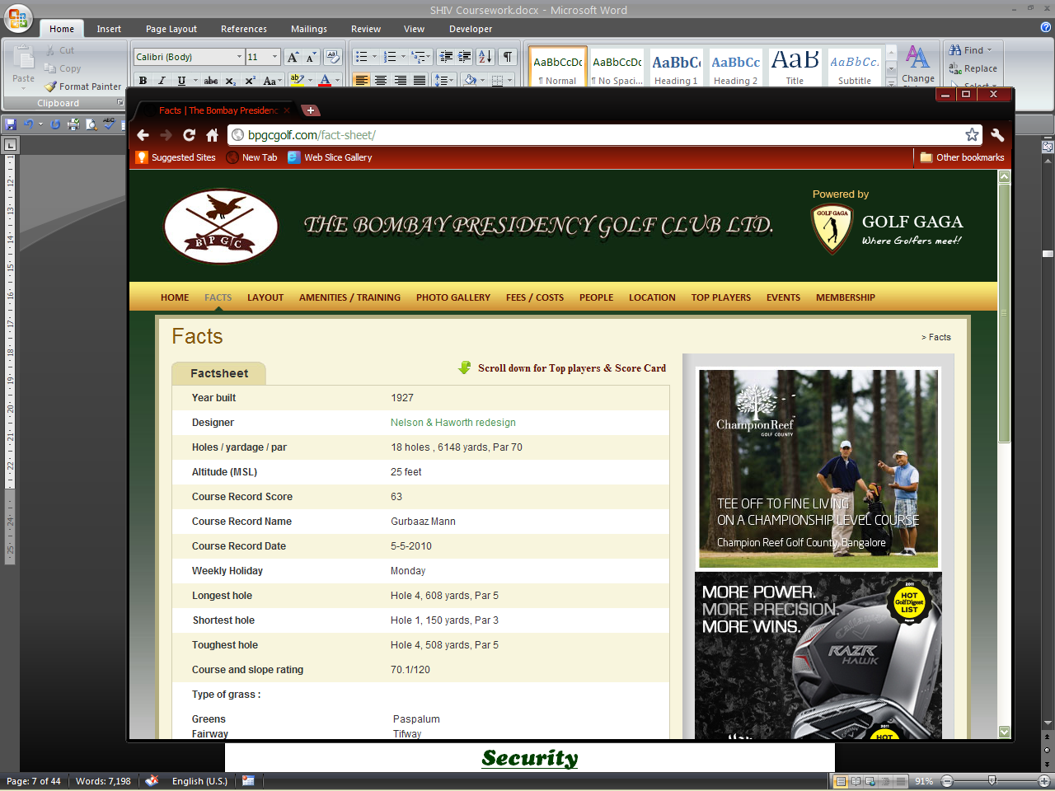

**EXIT**

**LOGIN**

**Golfers Page**

***Login Screen***

***Security***

The most important thing before any software is developed is to allow limited access to data as data can be misused. What’s the point of having a software if it can be manipulated by anyone? The main protection of this golf software is by a user ID and password. Simple, yet effective. It is necessary for the scorer’s team to maintain a record (book or file) of the number of people who have access to the password. Despite the fact that the system does save the date and time the passwords are changed it is always recommended to keep a record of when there has been a change in password and by whom. All the scores must be aware of a new user ID and password.

The software has a main login screen where only specific people can access the data held. This is the backhand of the display the golfers can view. All data can be updated from here.

Login Screen

Auto

Date:

User ID:

Password:

OK

***Main Menu***

After logging in the user of the system enters the main menu this main menu contains all the options that a user requires for the golf system.

Main Menu

Draw Maker

Tournaments

Handicap System

Golfer Profile manager

Change Password

Database

Foreign Club’s

Log out

The user of the system can change the user ID and password at their own free will. Whenever they want it is recommended to change these parameters once a month. By clicking on change password the user is taken to a new screen.

Change your user ID and password

Enter your current User ID:

Enter your new User ID:

Enter your current password:

Enter your new password:

Enter your new password:

Save

Cancel

The criteria’s are mandatory to be entered. The “reconfirmation of password” is a verification method to check if the new password is entered correctly by the user. The days at which the user Id and password are changed are also recorded.

***2.1 Profile manager***

The user must first in the inception of the system create a profile for golfers hence must choose the golf profile manager. This application is meant to manage the profile of each individual with accuracy and precision. Each member is given a unique key which in this case is their membership no.

The two classes of members are permanent and dependant members:

**Permanent members:** Are legally members of the club. They are given a letter followed by three numbers. Eg: (A-192)

**Dependant members**: Are dependent on another member for their membership as they may not be of the specific age of 21+. For dependant members they have the same membership no as their permanent host but with an extra digit at the end signifying the number they are dependent on. E.G : (A-192**4**) 4 signifies the fourth dependant member.

***Welcome to profile manager***

Edit

Delete

Search

Player membership no:

View all

Add a record

Reset Profile

Add a new member

* + 1. Add a new Member

Mship no Picture

Name

DOB

M/F M F

Mobil no

Addressee

Email iD

Cancel

Save

This is the first basic step in the golf system. The application requires a list of players who are members of the club. With each new entry a new profile for each member is created. The basic details of each member is entered. The picture of each member is obtained from a digital camera and saved in a specific folder. Each **file is labeled with the membership no.**

The membership number is the **primary key** in this and can be used to sort the data. This is then backed up immediately after created in the database.

Mship no- Primary Key (char) eg :D-934

Name-Character

DOB- Date

Male/Female- Boolean

Mobil no-Integer

Addressee- Character

Handicap- Double(18.5)

2.1.2 Reset Profile, Delete, Search, View All

These are the basic utility functions in this segment. They help the user manage the profiles.

1. The reset profile option is used to erase all existing data stored about the member. This includes all data like handicap’s, stats….ect, this is also deleted from the main database. The membership number is not deleted; the golfer profile will still exist.
2. The delete function deletes the entire user profile this includes the membership number and the profile from the main database. The golfer profile will not exist anymore
3. By entering the membership number the user can search a particular member faster.
4. The view all function shows all the user profiles without sorting.

2.1.3 Edit Profile

The edit function edits the user profile only the basic attributes of the golfer can be changed. It is similar to the new member screen. The picture can also be changed.

Edit Screen

Mship no Picture

Name

DOB

M/F M F

Mobil no

Addressee

Email ID:

Cancel

Save

2.1.4 Add a record

By clicking on add a record the system user must enter data for all the given categories in the following form. After saving the record all the data is added to the main database of the specific user. Then using the following data the system calculates:

Date Tees

*Name’s* Profile

|  |  |  |  |  |  |  |  |  |  |  |  |  |  |  |  |  |  |  |
| --- | --- | --- | --- | --- | --- | --- | --- | --- | --- | --- | --- | --- | --- | --- | --- | --- | --- | --- |
| Holes | 1 | 2 | 3 | 4 | 5 | 6 | 7 | 8 | 9 | 10 | 11 | 12 | 13 | 14 | 15 | 16 | 17 | 18 |
| Scores |  |  |  |  |  |  |  |  |  |  |  |  |  |  |  |  |  |  |
| Fairways hit |  |  |  |  |  |  |  |  |  |  |  |  |  |  |  |  |  |  |
| Greens hit |  |  |  |  |  |  |  |  |  |  |  |  |  |  |  |  |  |  |
| Sand Saves |  |  |  |  |  |  |  |  |  |  |  |  |  |  |  |  |  |  |
| Putts |  |  |  |  |  |  |  |  |  |  |  |  |  |  |  |  |  |  |

Auto

Gold

CANCEL

SAVE

The handicap of the golfer and adds it to the handicap database. Procedure: The system adds the values in the score row and uses the formula:

**Handicap differentia l= *(Score - Course Rating) x 113 / Slope Rating***

The course rating and slope rating are predetermined for each course according to the tees played on. Hence the system uses the total score along with the following data in the specific formula and stores the handicap differential in the database.

|  |  |  |  |  |
| --- | --- | --- | --- | --- |
|  | ***Gold*** | ***Blue*** | ***White*** | ***Red***  Table 1.1 |
| ***Slope Rating*** | 120 | 114 | 110 | 110 |
| ***Course Rating*** | 70.10 | 68.10 | 64.10 | 64.10 |

In the database we have the list of differentials sorted in **order of date.** The system user must then use the last **n** number of scores to calculate the handicap. The following table shows the value of **n** as rounds entered.

Eg: If the system user wants to calculate the handicap of the user over the last 14 rounds in the database the top 5 differentials (lowest scores) are used. Then to find the handicap a separate formula is used which is:

**Handicap= (Sum of differentials * 0.96)/ differential used**

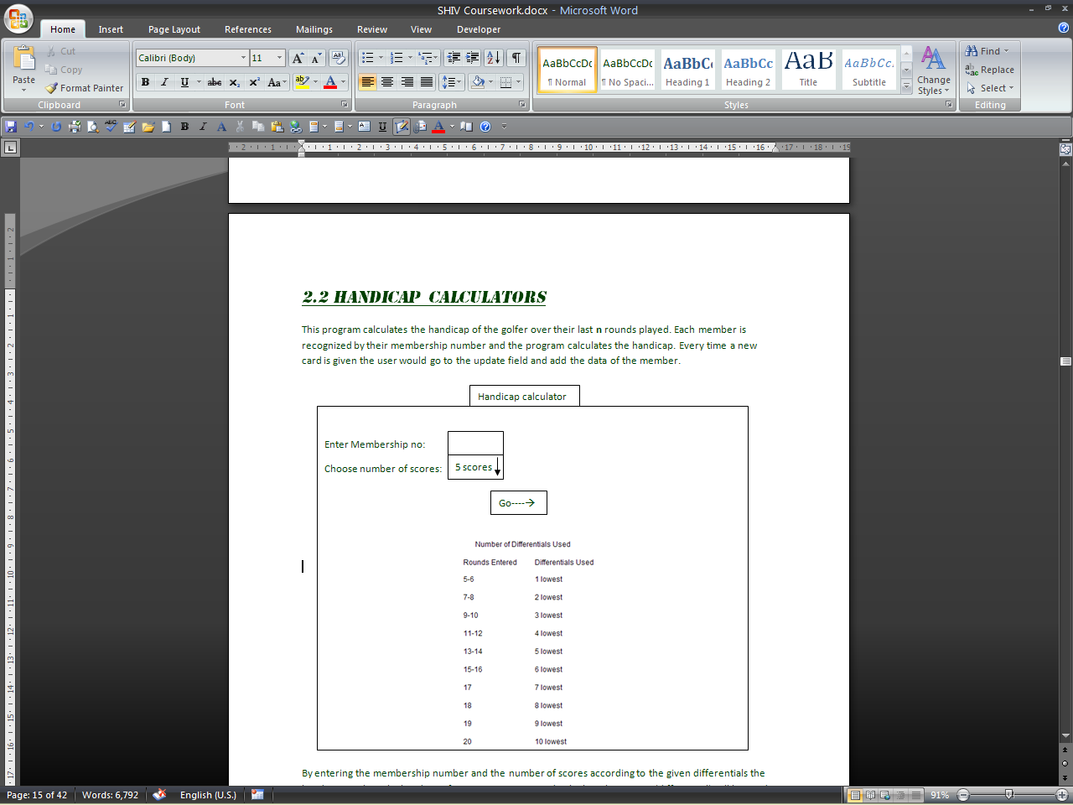In this case as we added the sum of 5 scores we would multiply the sum by 0.96 and divide by 5. Then this score is automatically added to the user’s handicap for the month. We drop off the last digit eg: If we get a handicap of 22.67 we take the handicap index as 22.6 we do not round off.

The database looks like this

Database of player XYZ Handicap (2012)

Date Score Tee Played Differential Calculated Calculate Handicap Index

17/01/12 92 Gold 20.62 Range of dates

To

Use top differentials

Handicap Index = _________

Dd/mm/yy

Dd/mm/yy

5

Add to golfer handicap file

Cancel

Now after we calculate the handicap index we must calculate the golfer’s handicap from different set of tees. This is added to the existing file on the golfer’s handicap.

Database of player XYZ Handicap Index (2012)

Tees

Date Handicap Index Gold Blue White Red

14/01/11 14.3 15 14 14 14

Delete

Eg: We have a golfer’s handicap Index of 14.3. The system must now use the formula:

**Handicap for tee = (Handicap Index* Slop Rating of tee)/113**

Now if we use the gold tee for our handicap calculations. We do (14.3*120)/113 that gives us 15.18 we round this off to the nearest whole number ie: 15 so this is the handicap of the golfer from the gold tee. Similarly the system carries out this function for all different tee’s using data as shown in table 1.1 This added row can also be deleted if the system user finds fault with this.

This handicap index page is available for the golfer to view in his profile the user can not edit or delete data stored. This is shown in the user interface (2.6).

***2.2 Handicap Calculator***

This program calculates the handicap of the golfer over their last **n** rounds played. Each member is recognized by their membership number and the program calculates the handicap. Every time a new card is given the user would go to the update field and add the data of the member.

Handicap Calculator

Enter Membership no:

Choose number of scores:

5 scores

Go----🡪

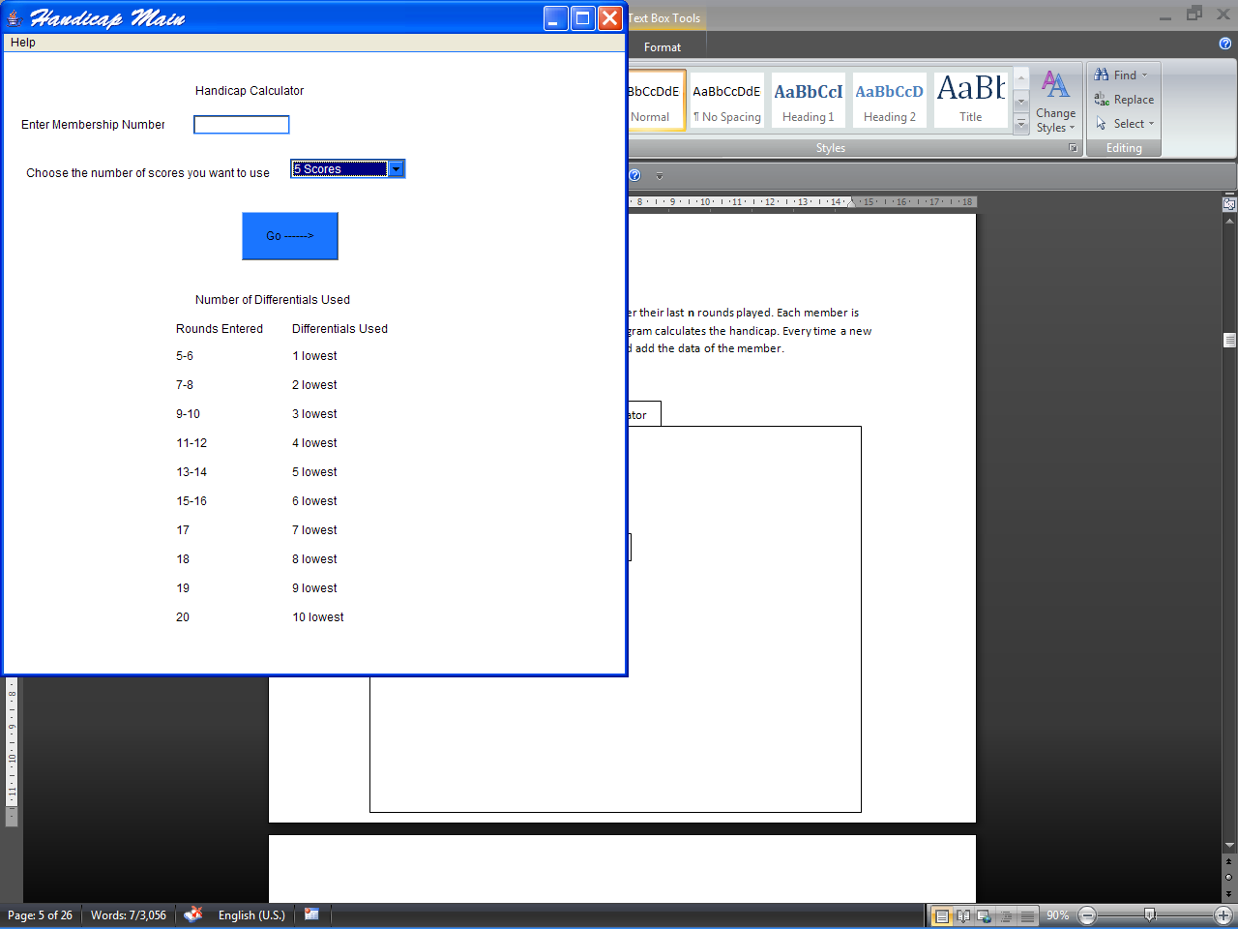

By entering the membership number and the number of scores according to the given differentials the handicap can be calculated. Eg: if 5-6 scores are entered only the 1 best score (differential) will be used in calculating the handicap. This is a direct method which is used for immediate results. The computer then calculates and saves this new handicap to the user page.

Handicap for last 20 scores

Enter your last 20 scores to calculate handicap Date

Score 1

Score 2

Score 3

Score 4

…………

Auto

Cancel

Save

This is a the second way in which handicap is calculated this is useful if the system user already has the total scores calculated on the scorecard. The scores are saved directly into the main user database as shown on page 16.

***2.3 Tournaments***

On weekend the club hosts tournaments where there are large crowds. Due to which there is a delay of scores (results arrive by evening due to manual processing). The results may not always be accurate. Most of the members are unsatisfied as they do not receive the scorers’ attention and are thus unable to find out their points in the game. The new system sets out to solve this problem by providing an instantaneous and accurate.

First the basic information about the tournament must be entered e.g.:

Welcome to tournament Creator

Enter the name of the tournament:

Choose the number of days:

Choose the number of players:

1

View Previous tournaments

GO----🡪

The user must then enter data manually in an input screen over a range of holes. For members entering the membership number is enough as the system searches the database for handicap& name then calculate scores. While during tournament where non members are involved these basic details must be entered manually.

Day:

1



………………

Gold

Tees:

Enter name

Enter score for hole 1

Enter score for hole 2

Enter handicap

The output format is displayed in ascending order of each of the categories given which can be sorted in the convenience of the user. This is for a one day tournament.

The results from the tournament would be further displayed in ascending order of the scores.

Name

Points for GOY

Score

Standing

**GOY**(Golfer of the year) is an award given to the best golfer of the club every year. This is a points system where on playing tournaments golfers get points according to their standings.eg: First place gets 10 points, Second 9 and so on. These points are again added to the user profile

Clicking on the name of the user takes us into the user profile for the tournament.

*Name of tournament *

Mship Name Scores Strokes Stableford Net Gross PPR % of greens hit

1 2 3 4 5 6 7 8 9 10 11 12 13 14 15 16 17 18

PPR=Putts per round

Some tournaments in golf last for up to 4 days. These are usually professional tournaments or organized by the club. Hence we need a system that is can store data over a few days. Hence for a 2-4 day tournament we have the following output screen with the same first input screen.

*Name of tournament*

*Day*

Mship Name Strokes Stableford Net Gross

PPR=Putts per round

1

Clicking on **name** you go to a new screen where data of the tournament will be recorded.

*Name’s Profile*

Day Scores Strokes Stableford Net Gross PPR % of greens hit

1 2 3 4 5 6 7 8 9 10 11 12 13 14 15 16 17 18

1

2

3

4

Handicap:

PPR=Putts per round



After this the output report is be **backed up in the database and saved**. The scores of each individual in the field strokes are **updated** to their **handicap** and their **statistics.**

Clicking on the view tournament options takes the golfer into a different form

Previous Tournaments

|  |  |  |  |
| --- | --- | --- | --- |
| Date Played | Name | Format | Criteria |
|  |  |  |  |
|  |  |  |  |
|  |  |  |  |
|  |  |  |  |
|  |  |  |  |

GO

GO

Back

By clicking on the go option the user is taken to the results form stored in the database of tournaments. Like the forms in the previous pages. The standings and details can all be viewed.

This option is available to the golfers and hence is repeated in the golfer interface design.

***2.4 Databases***

The database contains two functions which are backup and current database

Database

Add new database

Current databases

Backup

Z---------------

X -----------

Y---------------

Current databases

The database is a read only file where all data about a particular golfer can be viewed

Add new database goes to a new screen where the user gets to view only the users profile a ll editing must be done in the respective screens.

*Database Creator*

Name of new database:

2011

OK

When the current database is chosen a second screen is opened where there is a list of the members name along with their membership numbers. Clicking on the name takes the user to all details about the members.

Z------------

View

Golfer profiles

Tournament details

Foreign Club Details

GO

***Golfer Profiles (Each golfer has a specific file and all records are stored about him/her)***

Z---------------

Mship no Name

***Name***

Name

DOB

M/F

Mobil no

Addressee

Mship no

H-cap

Tournaments

Stats



View

View

View

Clicking on tournaments takes you to a new screen where each and every tournament entered by the player in that year is recorded.

Tournaments

Name of tournament Date Standings Scores Strokes Stableford Net Gross

1 2 3 4 5 6 7 8 9 10 11 12 13 14 15 16 17 18

Points 4 GOY

Similarly clicking on stats and handicap the user is taken to the respective screens.

***Tournament Details***

GO

Previous Tournaments

|  |  |  |  |
| --- | --- | --- | --- |
| Date Played | Name | Format | Criteria |
|  |  |  |  |
|  |  |  |  |
|  |  |  |  |
|  |  |  |  |
|  |  |  |  |

Back

GO

This is the same interface as viewing previous tournaments. Hence all the data that is stored after this linked from the *tournament file.*

**2.5.0 Foreign Clubs**

Handicap can also be calculated from clubs that players play around the world. The option *Non club handicap* must be chosen from the main menu.

After choosing this option there is a new window that opens up where

1. Create a new club altogether
2. Edit the statistics of a saved club
3. Delete a club
4. We can choose a club we have already created

Foreign Club Profile

GO

Choose Club

Delete Club

Add new Club

Edit Club Features

***2.5.1 Create Club***

We must first create a new club where it becomes easier to use the common data of the club to calculate the handicap of many players. After the club is created it is stored in the database

The values of important course features must be entered once and the course statistics are saved. For eg:

1. **Name:** The name of the club is needed to identify each club
2. **Stroke Index(SI):** Is the difficulty of the hole with 1 being the hardest and 18 being the easiest

|  |  |
| --- | --- |
| ***Score*** | ***Strokes*** |
| Double Bogey | 7 |
| Bogey | 6 |
| **Par** | **5** |
| Birdie | 4 |
| Eagle | 3 |
| Albatross | 2 |

1. **Par:** Is the number of strokes taken to complete a hole. Eg: if the hole is a Par 5. The following table shows the different scores possible per hole
2. **Course Rating: The Course Rating is a number, close to par for the course, and is expressed with a single decimal digit. For example: If par for a course is 72, its Course Rating might be 71.4.   
   Rating values go up with difficulty.   
   Actually, for any given golf course, you can expect to see three (or even more) values for the Course Rating. Each value corresponds to a different tee.   
   For example: On this same course, the Course Rating for golfers who play from the men's blue tees might be 72.8. From the men's white tees, the Course Rating might be 71.0.**
3. **Slope Rating:** The quick answer is that it's a single number indicating the difficulty of a golf course to a "bogey golfer". The figure is used when calculating handicaps.   
   The Course Slope value is a two- or three-digit integer, always between 55 and 155, with 113 being the average or "standard" value. There will be one Course Slope for each Course Rating. The blue men's tees might have a Course Slope of 123. The white men's tees: 119 and the ladies' red tees perhaps a 114. These figures are almost always printed on the score card
4. **Tees or (Tee box):** They are at different distances from the flag which increase in difficulty with increase in yardage. They are of different colors in each club e.g.: black is the most difficult tee, followed by blue ECT……….. Hence they must be entered individually. Below the tees the yardage of each hole must be entered.

New Club

Enter slope rating:

Enter name of the club:

Enter course rating

Tees

Par

SI

Hole 1

.

.

.

.

.

Course rating

Slope rating

CANCEL

SAVE

***2.5.2 Edit Club Features***

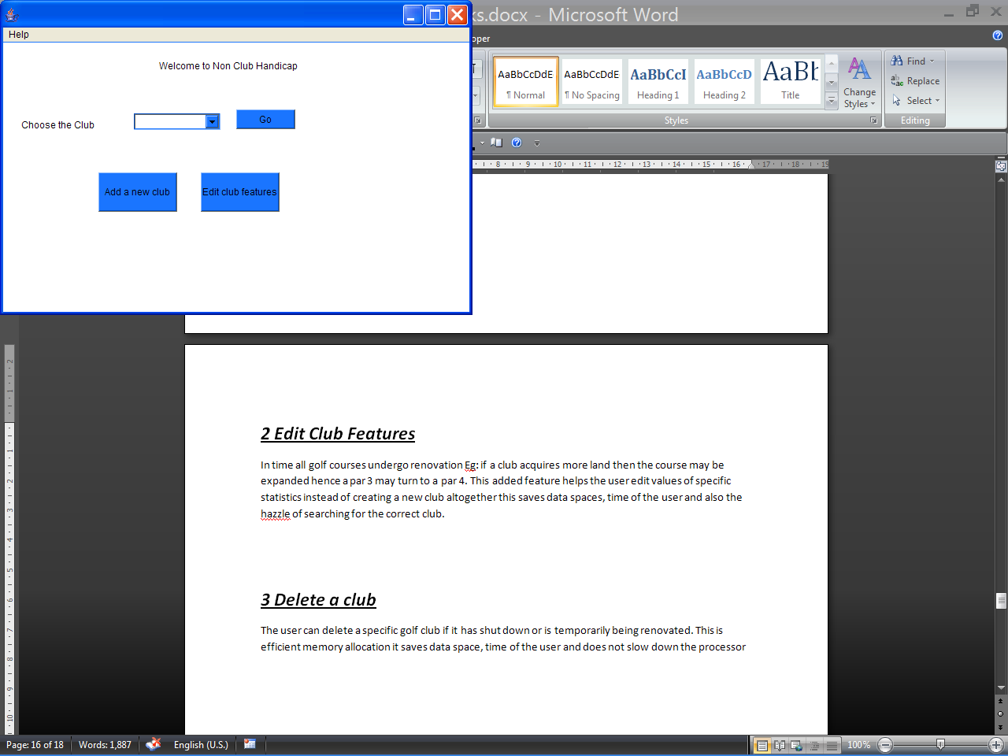In time all golf courses undergo renovation Eg: if a club acquires more land then the course may be expanded hence a par 3 may turn to a par 4. This added feature helps the user edit values of specific statistics instead of creating a new club altogether this saves data spaces, time of the user and also the hassle of searching for the correct club.

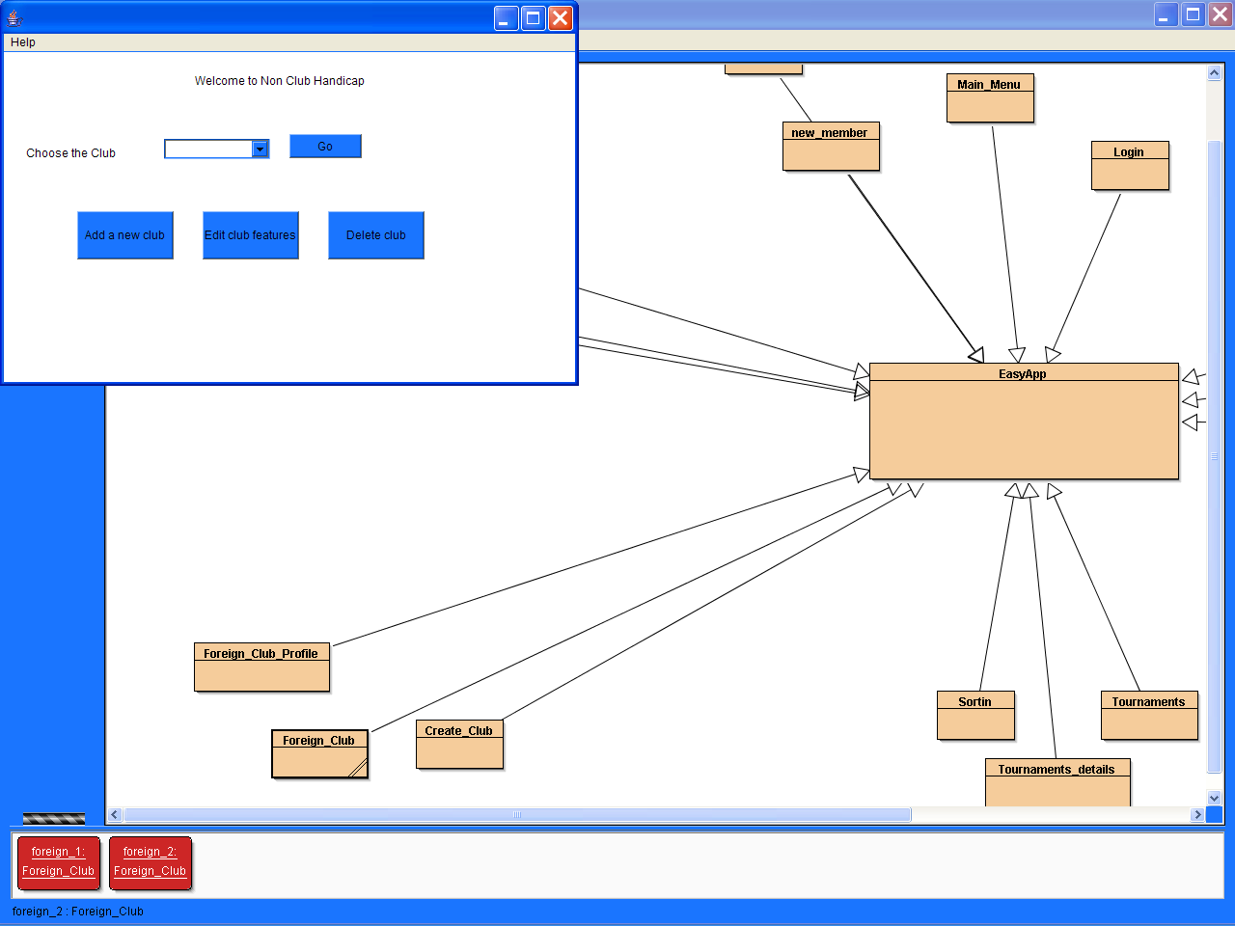***2.5.3 Delete a club***

The user can delete a specific golf club if it has shut down or is temporarily being renovated. This is efficient memory allocation it saves data space, time of the user and does not slow down the processor

***2.5.4 Existing club***

We can also choose an existing club from the list of clubs so we can add the scores of the players. These scores will automatically be used to calculate the handicap of the golfer. All criteria’s like strokes, putts ect… must be filled. These are used in the average for each golfer on each hole for **this particular course**. The gross score can be used to calculate the golfer’s handicap.

Club specified

Auto

Date Tees

Enter membership no

*Name’s* Profile

|  |  |  |  |  |  |  |  |  |  |  |  |  |  |  |  |  |  |  |
| --- | --- | --- | --- | --- | --- | --- | --- | --- | --- | --- | --- | --- | --- | --- | --- | --- | --- | --- |
| Holes | 1 | 2 | 3 | 4 | 5 | 6 | 7 | 8 | 9 | 10 | 11 | 12 | 13 | 14 | 15 | 16 | 17 | 18 |
| Scores |  |  |  |  |  |  |  |  |  |  |  |  |  |  |  |  |  |  |
| Fairways hit |  |  |  |  |  |  |  |  |  |  |  |  |  |  |  |  |  |  |
| Greens hit |  |  |  |  |  |  |  |  |  |  |  |  |  |  |  |  |  |  |
| Sand Saves |  |  |  |  |  |  |  |  |  |  |  |  |  |  |  |  |  |  |
| Putts |  |  |  |  |  |  |  |  |  |  |  |  |  |  |  |  |  |  |

CANCEL

SAVE

***2.6.0 Draw maker***

A draw is a grouping of players before a tournament. Before a tournament, golfers sign up for the tournaments. The scores then add the names of the golfers in groups of three or four (known as three or four balls respectively) along with the times they must start.

***Draw Maker***

***Golfers Page***

***2.7.0 The Golfer Interface***

We must use a Graphical User Interface so that it is easy for an average golfer to view all their details. This is only meant for the golfer who uses a touch screen monitor to navigate through the system. They can only view their profile not edit it. This is also in control of the system operator who can navigate on their computer but cannot edit as the main editing must be done in the main system.

The Bombay Presidency Golf Club

Player Profiles

View draws for tournaments

Tournament Results

Upcoming Tournaments

***2.7.1 Player profiles***

This feature helps average golfers view statistical information about his game making it easier for him/her to get a better understanding of their game. This helps them identify the problems in their game and work on them accordingly to play better. This is a read only file which players can view they cannot change any of the data. This can also be viewed by the system user but any editing must be done in the main system.

Player Statistics

Enter Mship no:

GO-->

Entering the membership number takes you to the user profile

The user profile is subdivided into different sections to make it easier for the user to access the information about their golf game.

XYZZ------Profile

2010

Year:

Handicap

View my:

2011….

Tournament details

Game Stats

Rounds Stats

Foreign Clubs Stats

**GO**

The year function allows the user to sort out his/her statistics season wise and helps the user find out the change in their game over the years.

**2. 7.1.1]Tournament Details:** This function helps a user view the number of tournaments he/she has entered and this records their scores and statistics about the different tournaments they have been part of.

The statistics are **only** a record for the tournaments a golfer enters. This helps a golfer see his performances during tournaments over the range of holes. This can help a golfer choose which holes he is good at and in which he plays an average game. Hence allowing the golfer to choose his holes to “attack” with greater precession backed with this hard data.

*Name’s* Profile

Name of tournament Date Standings Scores Strokes Stableford Net Gross

1 2 3 4 5 6 7 8 9 10 11 12 13 14 15 16 17 18

Points 4 Golfer of the year

Statistics

Hole Bogeys Pars Birdies Eagles Albatrosses Hole in One Others Sand Shots Putts Drives GIR Average score GOY

1

2…..

Average greens in Regulation:

Average putts per round:

Average fairways hit:



This should be updated from the database eveytime.

**2.7.1.2] Handicap Details:** A **handicap** is a numerical measure of an amateur golfer's playing ability based on the tees played for a given course. Lower the handicap better the golfer.

When the handicap option is chosen the user is redirected to a new screen where all details of his handicap are displayed in the following order.

----------------- Handicap

View all:

Search:

Enter month you want to view:

2012

Month Handicap

Handicap Index Gold Blue White Red

January

February

March

April

May

June

July…

This screen shows the monthly handicaps of the golfers with the handicap index. This is a quick view of the handicaps of a golfer over a year.

*Handicap Index:* is a numeral, to one decimal place, that represents a golfer's potential for scoring. A handicap index of 14.5, for example, indicates that a golfer will, on his or her best days, shoot somewhere around 14 or 15 strokes over par from the tees as given(gold,blue,white,red)

When the user enters the month he wants to view a new screen is opened where. Details about the game for the month is given. This helps the user recollect the data over his games over a period of time which otherwise would be unavailable as the handicap cards are disposed off after the scores are taken.

January

Scores

|  |  |  |  |  |  |  |  |  |  |  |  |  |  |  |  |  |  |  |  |  |
| --- | --- | --- | --- | --- | --- | --- | --- | --- | --- | --- | --- | --- | --- | --- | --- | --- | --- | --- | --- | --- |
| 1 | 2 | 3 | 4 | 5 | 6 | 7 | 8 | 9 | **35** | 10 | 11 | 12 | 13 | 14 | 15 | 16 | 17 | 18 | **35** | **70** |

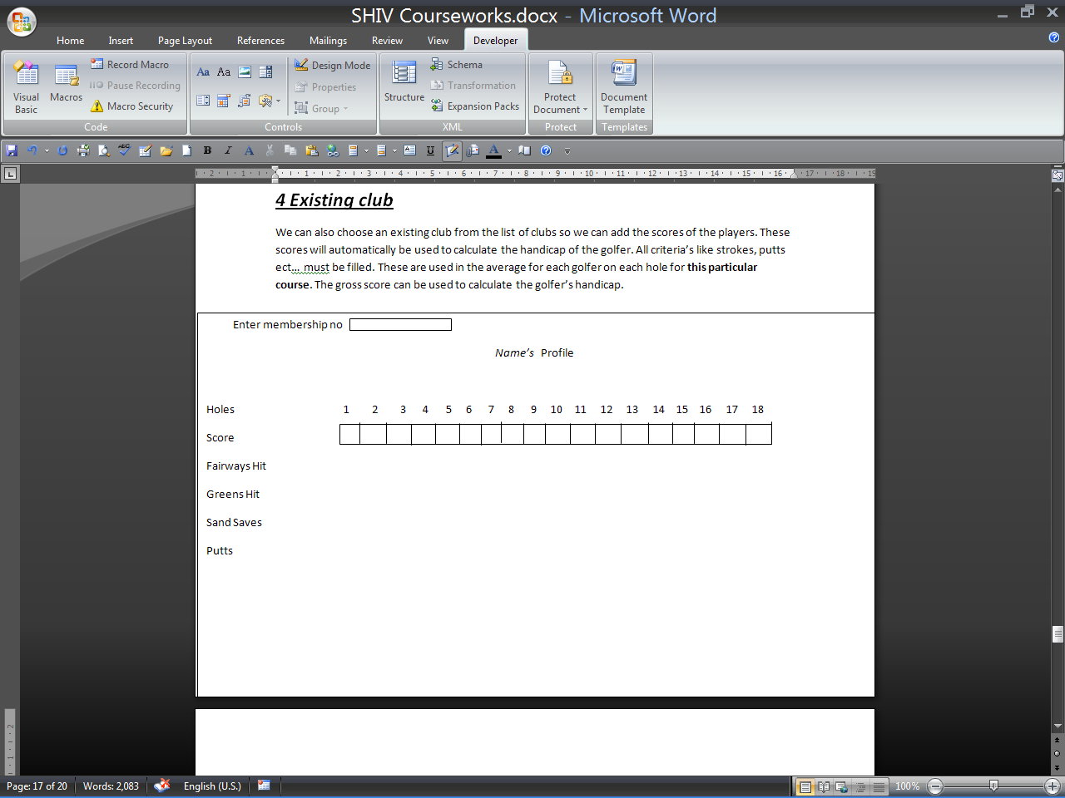

19/07/11

Date

19/07/12

View month stats

Clicking on view month stats takes the user into his profile on his scores in profile mode. The view month’s statistic takes the user to his statistics for the specific month (next).

**2.7.1.3] Game Stats:** This feature gives a golfer all possible statistical reports on their game.

The main features of this program are;

1. **Calculates gross score:** It is the total number of strokes a golfer takes to complete the round e.g.: If after 18 holes if 78 strokes are taken 78 is the gross score.
2. **Calculate net scores:** Is the score adjusted with the handicap of a golfer e.g.: if after 18 holes the gross score is 78 and the golfer has a handicap of 5. The course par is 72 so the golfer has played 6 over the course par and 1 over his handicap of 5. *+1 is the net score*
3. **Calculates stableford points:**  Is a point system in golf where on each hole the golfer is given a point relative to the score he makes. The following table shows the stableford points table.

|  |  |
| --- | --- |
| ***Score*** | ***Points*** |
| Double Bogey | 0 |
| Bogey | 1 |
| **Par** | **2** |
| Birdie | 3 |
| Eagle | 4 |
| Albatross | 5 |

1. Average score over **n rounds** on each hole : Is the average score of a golfer over a number of rounds this helps the golfer view his performances over a period of time
2. Golfer statistics:
   * 1. % Greens in regulations,
     2. putts per round,
     3. % fairway drives,
3. Statistics: Birdie, par, eagles.. ect on all holes and average of these values
4. The user can specify dates over which these values must be calculated.
5. The profile also records data of all tournaments played by the golfer and saves the scores for late use.

The following page shows the user interface for this particular application.

View all

Gold

---------------Profile

More..

ALL STATS

Hole Yards Par Avg Score

1

2

3

4

5

6

7

8

9

10

11

12

13

14

15

16

17

18

Sort:

Jan

More..

More..

Enter Dates:

DD/MM/YY

DD/MM/YY

The view all option shows all the basic details (as shown on the right side of the screen). With default tee set as gold the average score for the holes may be 0 if the player does not play from the gold tee. The month wise sorting takes only the scores that month and displays it. While the date range option gives the user flexibility to choose a date range so he/she can view their progress over that period of

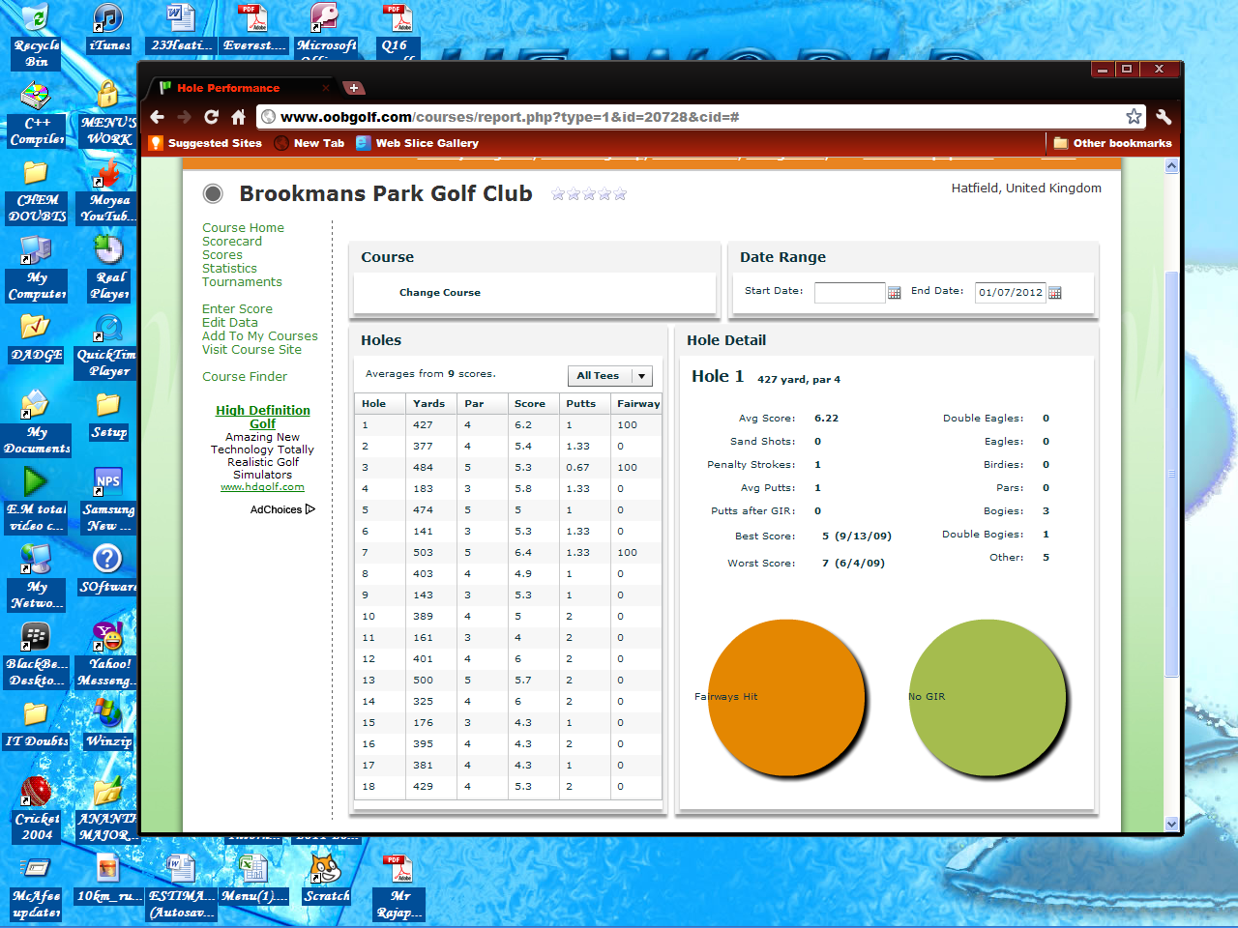

January or (Range of dates)

---------------Profile

Hole Yards Par Avg Score

1

2

3

4

5

6

7

8

9

10

11

12

13

14

15

16

17

18

Gold

Jan

Sort:

DD/MM/YY

Enter Dates:

View all

More..

More..

More..

Fairways hit: x/18

DD/MM/YY

Rounds so far :

Avg Putts: *Z*

Greens hit: y/18

Time. For example the user sorts the data according to January. The yards and par are predefined according to the course.

The fairways hit x/18 signifies the number of fairways hit in every 18 holes this is an average value from the given range by the user. This is the same for putts and greens hit. Clicking on the **more** option takes the user into a more in-depth analysis of each hole and their scores. The blue box shows the number of rounds played by the golfer during the range specified. By default it is the total number of rounds each year.

Pars:

Birdies:

Eagles:

Albatross:

Bogey:

Double Bogeys:

Others:

Avg Score:

Sand Shots:

Avg Putts:

Greens in Regulation:

Fairways hit:

Best Score: 4 (Date)

Worst Score: 12(Date)

HOLE 1 515 yards Par5

% Greens hit

% Fairways hit

**2.7.1.4] Rounds:** When a golfer plays a round of golf he notes down his score on a scorecard. The scores from this card are used to calculate the scores during tournaments. Then the handicap is calculated and the cards are disposed off. There has never been much of a problem with this method but the major disadvantage is that golfers cannot see their scores whenever they want. For eg: If a golfer wants to see his/her best score and it was about one month before. The golfer cannot access the scores. The new system intends to solve this problem by the user entering data about the rounds and then saving this in the database according to the date played. These gross and net values are updated to the user handicap. The scores on each hole and other statistics are updated in the user profile. This application stores all the scores of the user over 18 holes.

-------- Rounds Played

January

Sort month:

DD/MM/YY

DD/MM/YY

Enter Dates range:

January or (Range of dates)

|  |  |  |  |  |  |  |  |  |  |  |  |  |  |  |  |  |  |  |  |  |  |
| --- | --- | --- | --- | --- | --- | --- | --- | --- | --- | --- | --- | --- | --- | --- | --- | --- | --- | --- | --- | --- | --- |
| **Holes** | | | | | | | | | | | | | | | | | | | | | |
|  |  |  |  |  |  |  |  |  |  | **In** |  |  |  |  |  |  |  |  |  | **Out** | **Total** | |
| Dates | 1 | 2 | 3 | 4 | 5 | 6 | 7 | 8 | 9 | **35** | 10 | 11 | 12 | 13 | 14 | 15 | 16 | 17 | 18 | **35** | **70** | |
|  |  |  |  |  |  |  |  |  |  |  |  |  |  |  |  |  |  |  |  |  |  | |

**2.7.1.5] Foreign Clubs:** A golfer can view all his statistics of his rounds in other foreign clubs other than BPGC. After the golfer chooses this in the main menu.

Foreign Club

OK

Choose your club:

When the golfer chooses the club in which he wishes to view his stats a new window is opened. Which is similar to the user’s profile in the home club choosing the more category again takes the user into the more detailed version of each hole.

--------------- Club Profile

Gold

More..

More..

Hole Yards Par Avg Score

1

2

3

4

5

6

7

8

9

10

11

12

13

14

15

16

17

18

View all

More..

View my rounds

Fairways hit: x/18

Greens hit: y/18

Avg Putts: *Z*

Rounds so far :

Back

Avg Score:

Sand Shots:

Avg Putts:

Greens in Regulation:

Fairways hit:

Best Score: 4 (Date)

Worst Score: 12(Date)

HOLE 1 515 yards Par5

Pars:

Birdies:

Eagles:

Albatross:

Bogey:

Double Bogeys:

Others:

% Fairways hit

% Greens hit

Clicking on the view my rounds button takes the user to his scores on that course for each and every round.

-------- Rounds Played

January or (Range of dates)

|  |  |  |  |  |  |  |  |  |  |  |  |  |  |  |  |  |  |  |  |  |  |
| --- | --- | --- | --- | --- | --- | --- | --- | --- | --- | --- | --- | --- | --- | --- | --- | --- | --- | --- | --- | --- | --- |
| **Holes** | | | | | | | | | | | | | | | | | | | | | |
|  |  |  |  |  |  |  |  |  |  | **In** |  |  |  |  |  |  |  |  |  | **Out** | **Total** | |
| Dates | 1 | 2 | 3 | 4 | 5 | 6 | 7 | 8 | 9 | **35** | 10 | 11 | 12 | 13 | 14 | 15 | 16 | 17 | 18 | **35** | **70** | |
|  |  |  |  |  |  |  |  |  |  |  |  |  |  |  |  |  |  |  |  |  |  | |

DD/MM/YY

DD/MM/YY

Enter Dates range:

January

Sort month:

***2.7.2 Upcoming tournaments***

Golfer’s can enter their names for tournaments which would be played in the club this is a more foolproof and effective method of maintaining this information

***Upcoming Tournaments***

|  |  |  |  |
| --- | --- | --- | --- |
| Date | Name | Format | Criteria |
|  |  |  |  |
|  |  |  |  |
|  |  |  |  |

GO

GO

Clicking on go takes the golfer onto a new screen where he/she can enter their names for the tournaments.

XYZ Tournament (Date)

Format: Criteria: Handicap<24

|  |  |  |  |  |  |  |
| --- | --- | --- | --- | --- | --- | --- |
|  |  |  |  |  |  |  |
|  |  |  |  |  |  |  |
|  |  |  |  |  |  |  |
|  |  |  |  |  |  |  |
|  |  |  |  |  |  |  |
|  |  |  |  |  |  |  |
|  |  |  |  |  |  |  |
|  |  |  |  |  |  |  |
|  |  |  |  |  |  |  |
|  |  |  |  |  |  |  |
|  |  |  |  |  |  |  |
|  |  |  |  |  |  |  |
|  |  |  |  |  |  |  |
|  |  |  |  |  |  |  |
|  |  |  |  |  |  |  |

Add your membership no

***Back***

Membership no:

GO

D-2

D-26

D-294

Clicking on the empty boxes the golfers can enter their membership no’s so that the system identifies the name and handicap of the golfer. This comes into the boxes in the previous screens.

***2.7.3 Tournament Results***

Clicking on the view tournament options takes the golfer into a different form

Previous Tournaments

|  |  |  |  |
| --- | --- | --- | --- |
| Date Played | Name | Format | Criteria |
|  |  |  |  |
|  |  |  |  |
|  |  |  |  |
|  |  |  |  |
|  |  |  |  |

GO

GO

Back

By clicking on the go option the user is taken to the results form stored in the database of tournaments. As shown on page 19,20. The golfer’s can view all previous tournament results.